SDF 2026/27: A Funding Decision Affecting Cheshire Practices  Cheshire LMC · July 2026 | 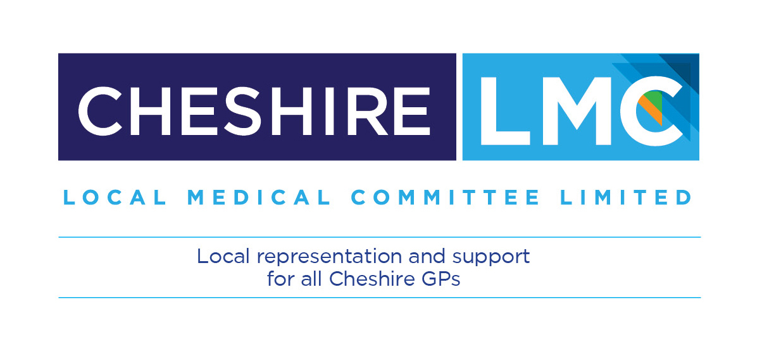
  UPDATE TO PRACTICES

In brief
Cheshire and Merseyside ICB has changed how it distributes £2.04m of System Development Funding for general practice in 2026/27. The money is now shared out using a single measure: avoidable mortality. Seventy-two of Cheshire’s 79 practices receive less than they would on an equal share per patient, and seven receive more. Cheshire as a whole receives about £197,000 less. This note explains how the decision works, what it means for your practice, and what the LMC is doing.

What has happened
The £2.04m supports Neighbourhood Health development and winter resilience. The ICB Executive Committee decided to allocate it to PCNs using a health inequalities formula based solely on avoidable mortality: deaths, mostly before the age of 75, considered preventable or treatable. The formula and its underlying data are published by NHS England in the Health Inequalities Adjustment model for 2026/27 to 2028/29.
Each practice is given a need index on a scale where the England average is 1.00. The pot is then shared in proportion to each practice’s registered list multiplied by that index. The average index across Cheshire and Merseyside is 1.324. A practice above that line receives more than an equal share per patient; a practice below it receives less. The proportion you gain or lose depends only on your index. It does not depend on the size of your list.
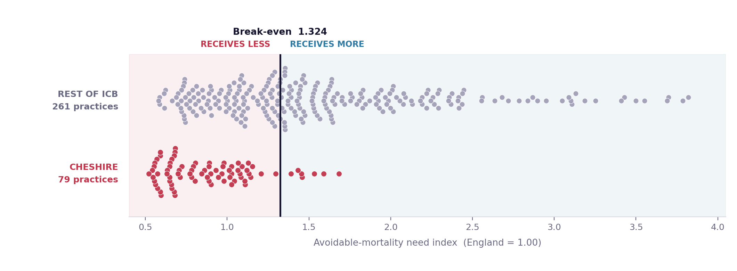
Every practice in Cheshire and Merseyside, placed on the need index. Cheshire practices sit almost entirely below the break-even line.
The formula favours areas with high rates of premature death, and so benefits practices serving more deprived populations. That includes seven practices within Cheshire itself. It disadvantages practices where patient complexity arises from frailty, dementia and age-related conditions rather than early death.

The impact on Cheshire
The effect varies widely across Cheshire’s 79 practices. Seven gain, because their need index sits above the ICB average. Seventy-two receive less than an equal share per registered patient. Individual practice effects range from roughly +27% to −61%.
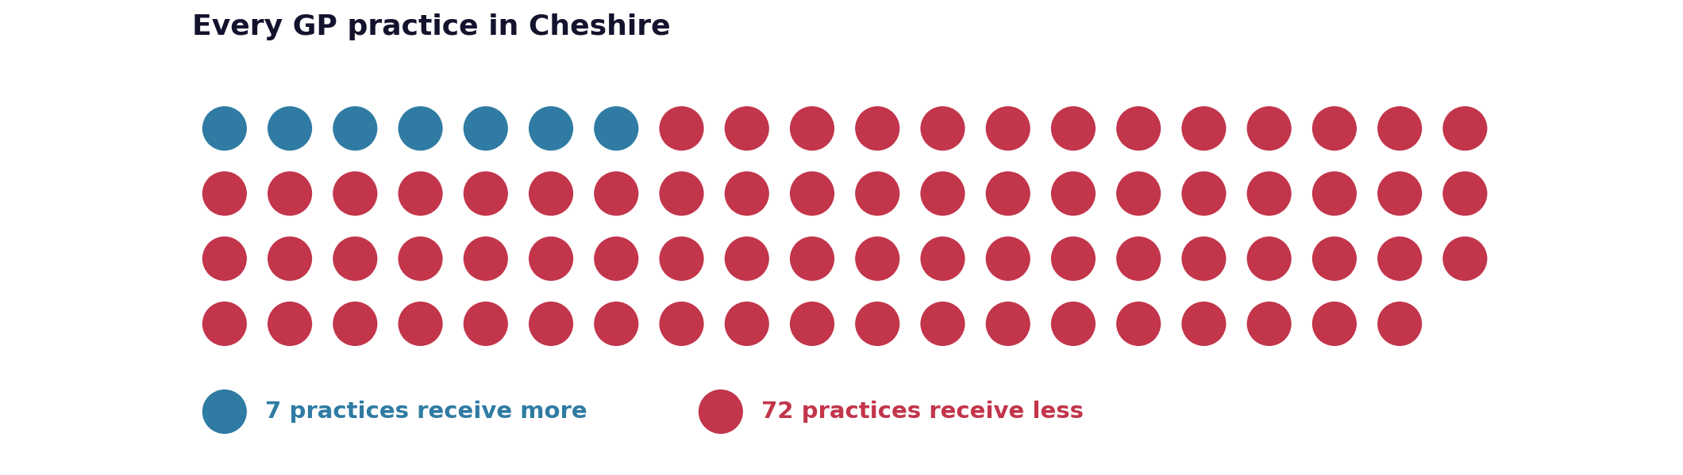
Area | Funding effect | Percentage change
Cheshire East | −£112,775 | −34.5%
Cheshire West and Chester | −£84,071 | −29.3%
Cheshire total | −£196,846 | −32.7%

Across the wider ICB, Liverpool gains approximately £166,000, or 38%, while Cheshire loses a similar sum. In practice, this pot operates as a transfer between the two areas.
Because the formula multiplies your list by your index, two very differently sized practices can receive the same money. The example below is drawn from the ICB’s own model.
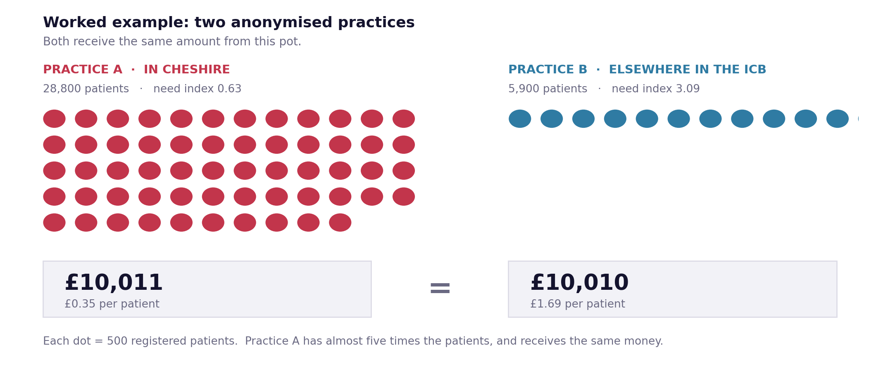
The formula multiplies each list by its index, so it treats these two practices as the same size.

Why this matters
For practices that gain, the additional resource supports work with populations experiencing higher premature mortality, where health inequalities are most acute. That is a legitimate purpose and the LMC does not dispute it.
For practices that lose, capacity to develop services and respond to winter demand is reduced. The cost of delivering care does not fall simply because the funding does. Part of this money is for winter resilience, and winter pressure is driven heavily by the frail elderly. That is precisely the population an avoidable mortality measure does not capture: a patient who dies frail at 84 does not register as an avoidable death.
The weight given to this measure
Nationally, avoidable mortality is one component of need among many. NHS England weights it at 10.2% of core ICB funding and 15% of primary medical care funding. The remaining 85% to 90% covers age, morbidity, prescribing, community services, maternity and mental health. For this pot, the ICB has used avoidable mortality on its own. NHS England does not allocate SDF this way nationally.

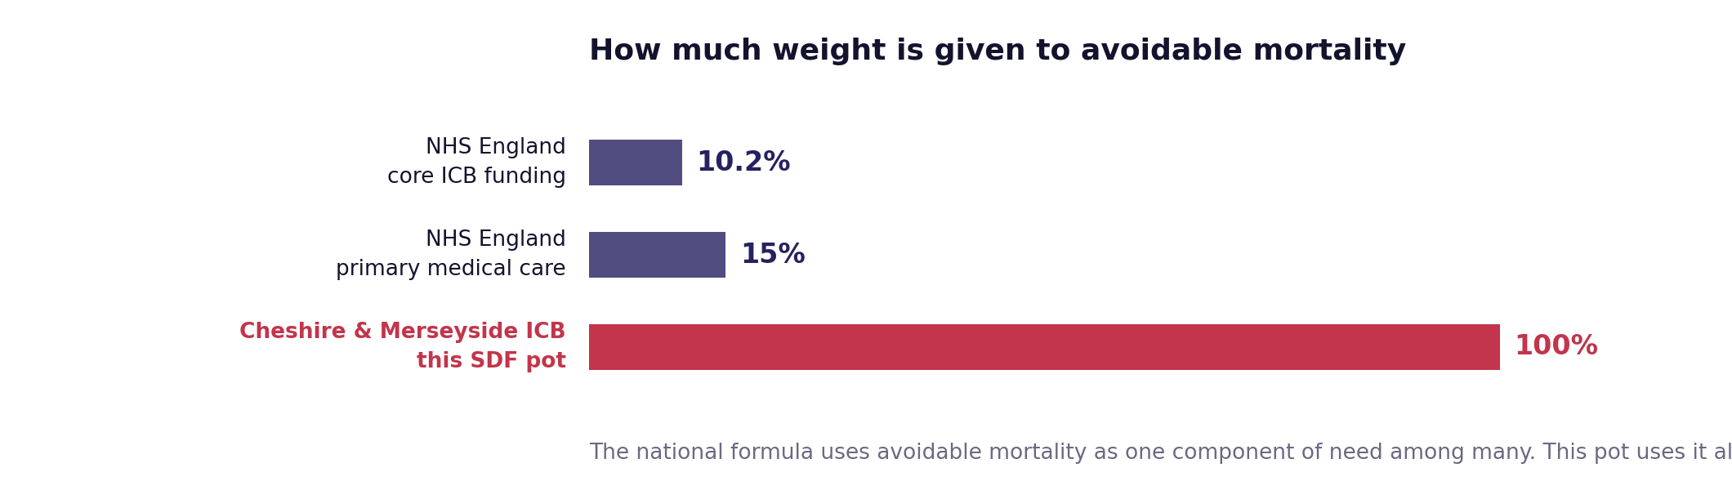

The LMC’s concerns
1. The measure does not capture our patients.: Avoidable mortality measures premature death. It is not a measure of frailty, multimorbidity or workload, which is where much of the complexity in Cheshire lies.
2. A single component has been used alone.: The national formula treats avoidable mortality as 10% to 15% of need. The ICB has applied it as 100% of the basis for this allocation.
3. No impact assessment has been published.: The ICB has not shared an assessment of the financial effect of this decision on individual practices or PCNs. The LMC has had to model that effect itself.
4. Clinical leads were not engaged on the method.: The LMC has not seen evidence that PCN clinical directors or neighbourhood clinical leads were engaged in developing the formula before it was applied.
5. This was a local choice, not a national requirement.: SDF now sits within the ICB’s general baseline with no ringfence. No national rule required this money to be allocated on avoidable mortality, or on any formula at all. The decision, and the method, belong to the ICB.
The precedent
Because the proportions depend only on the need index, this method would produce the same percentage reductions for the same practices whatever sum it was applied to. £2.04m is a small pot. The LMC will be seeking assurance that this approach is not treated as settled for future funding streams without the impact assessment, consistency review and clinical engagement that a decision of this kind warrants.

What happens next
The LMC is:
- Seeking a full response from the ICB on the decision, its rationale and the process followed.
- Requesting the impact assessment and the Executive Committee’s papers and reasoning.
- Asking what review was undertaken of existing funding differences that already reflect health inequalities.
- Seeking assurance on how this method may or may not be applied to future funding.
Practices and PCNs may wish to:
- Align PCN activity plans to the funding actually received, and record clearly what can and cannot be delivered as a result.
- Raise the local impact with MPs, councillors and Patient Participation Groups.
- Send specific examples and concerns to the LMC, which will use them in its representations to the ICB.
Data sources: https://gbr01.safelinks.protection.outlook.com/?url=https%3A%2F%2Fwww.england.nhs.uk%2Fwp-content%2Fuploads%2F2025%2F12%2Fg-health-inequalities-adjustment-2627-to-2829.xlsx&data=05%7C02%7Cdavidward4%40nhs.net%7Cd89e4a7248864b9482bc08dee2625e87%7C37c354b285b047f5b22207b48d774ee3%7C0%7C0%7C639197109283956740%7CUnknown%7CTWFpbGZsb3d8eyJFbXB0eU1hcGkiOnRydWUsIlYiOiIwLjAuMDAwMCIsIlAiOiJXaW4zMiIsIkFOIjoiTWFpbCIsIldUIjoyfQ%3D%3D%7C0%7C%7C%7C&sdata=Cwdt40%2B0PMunpzmrorc9Kz5eQ77VrV33XBCIoUa8U04%3D&reserved=0

